

**Head of Development**

**CLOSING DATE: Monday 22nd March 2021, Noon**

**INTERVIEWS TO BE HELD: 29th March 2021**

**A JOURNEY OF EDUCATIONAL EXCELLENCE THROUGH OUR FAMILY OF SCHOOLS**

**EMPLOYMENT OPPORTUNITIES**

**BURY GRAMMAR SCHOOLS**

**“A positive and uplifting environment”**

**THE GOOD SCHOOLS GUIDE, 2018**



**WELCOME**

**WHY JOIN BURY GRAMMAR SCHOOL?**

Bury Grammar School is a forward-thinking, vibrant and modern family of schools. We are proud of our rich heritage and the tradition of academic excellence combined with exceptional pastoral care. Our aim is to offer an outstanding and unrivalled education in which pupils are inspired to work hard, aim high and achieve. We have a strong commitment to retaining the long-held traditions, values and ethos of each of the Bury Grammar Schools, while preparing pupils for lives in an ever-changing world. We take enormous pride in our 450-year history, whilst looking to the future with confidence, openness and optimism. We are proud to be a leading academic school with a big heart.

Bury Grammar School is a dynamic and exciting place to work and employs over 230 staff across a wide variety of roles. Every member of staff employed by Bury Grammar School has an impact on our pupils and we aim to recruit the highest calibre professionals who are passionate about our school aims: Scholarship, Character, Partnership and Enrichment.

We foster strong leadership and management by empowering and involving staff in strategy and decisions. We have an established CPD programme that provides our staff with every opportunity to continue their own learning journey. We recognise that delivering continuous improvement is key to the success of every individual and to Bury Grammar School as a whole and we value all our staff and believe that attracting and retaining the very best people is fundamental to allowing us to continue to develop. In short, we aim to be both an excellent school and an excellent employer.

Most unusually in the independent sector, our pupil roll is growing: our Primary Schools are flourishing and both Senior Schools recently moved from three to four-form entry. Our excellent results are improving still further, the School’s reputation is thriving and in 2020 the School celebrates its 450th birthday.

This is the perfect moment to join Bury Grammar School.

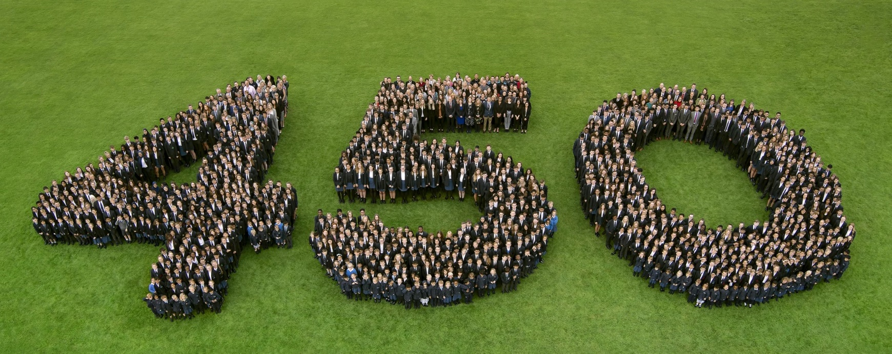

**BENEFITS OF WORKING AT BGS**

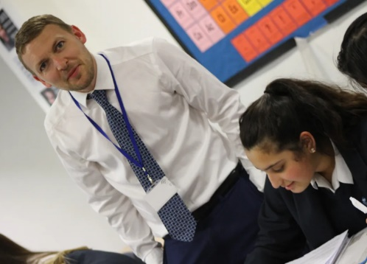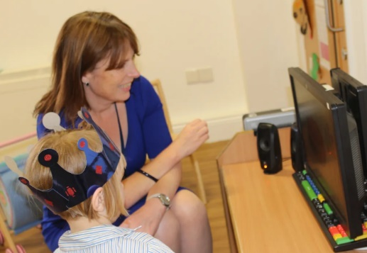



At BGS, we value our staff highly and recognise that all our staff are our most important asset. Our aim, therefore, is to ensure that all staff at BGS receive high quality provision for their developmental needs so that the education we provide our pupils is of the highest standard.

The school also seeks to enable those who wish to progress their careers into middle and senior leadership to be enabled to do so whether such opportunities arise at BGS or elsewhere. In addition, we want colleagues to feel empowered to take the initiative, to run with their own ideas and to consider that they are always learning. By having such a mind-set we are role models for the behaviour we want our pupils to adopt.

We pride ourselves on the best support and care for our academic, support and bursarial staff as we believe firmly that a school is only as strong as those working within it.

In addition our staff enjoy the following benefits:

* Pension Scheme
* Induction, support and personal development
* Family-friendly policies
* Generous lunch allowance in our School Dining Hall
* Above average annual leave entitlement
* Free access, at stipulated times, to our extensive sports facilities
* Friendly staff common room and active programme of social activities
* Cycle to Work salary sacrifice scheme
* Access to borrow books from our library
* Fee remission scheme
* Specsavers Corporate Eye Care Scheme
* Free Parking on site
* Pay progression
* Free afterschool club care

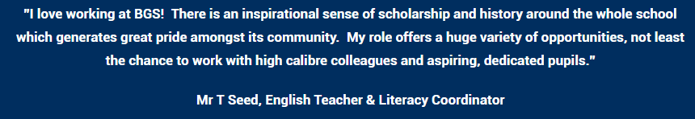

**UNIQUE STRUCTURE**

**Diamond model school**

Bury Grammar School is a ‘diamond model’ school which means that it combines both single-sex and co-educational teaching in the same organisation.

The youngest children are taught in co-educational teaching groups in the purpose-built Kindergarten and Infant School. Pupils are then taught in single-sex teaching groups in separate buildings from Year 3, which continues until the pupils complete their GCSEs, although there is some co-educational teaching.  After GCSEs pupils progress into the purpose-built co-educational Sixth Form for their A Level study.

We believe that our model provides the ‘best of both worlds’ within our family of schools. During the pupils’ formative years (between Years 3-11) they have the focus of single-sex teaching and tutor groups which allow lessons to be specifically tailored to their needs.

Pupils are able to mix socially outside of lessons and extra-curricular activities are mixed.

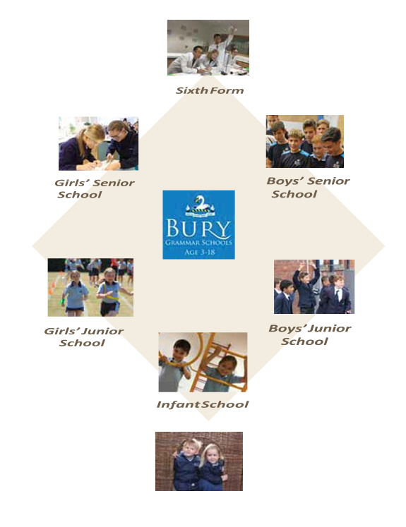

**LEADERSHIP STRUCTURE**

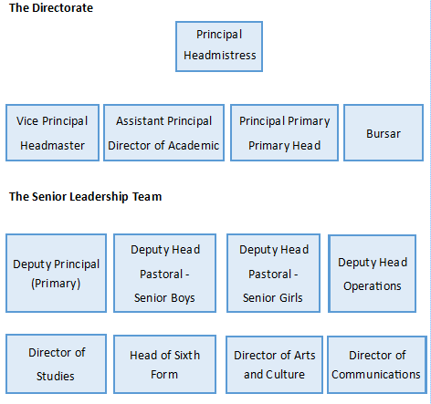

What makes Bury Grammar School so successful? From a leadership perspective, it is our collaborative ethos, the absolute commitment of every leader to the whole school and not just their ‘own’ area, a willingness to work together and be generous with ideas and time, and an unwavering focus on what is best for the pupils. We also enjoy each other’s company and take a pride in each other’s achievements. All new members to the team must actively support this collaborative ethos if they and the School are to succeed; and of course this approach makes life as a BGS senior leader all the more rewarding.

The School operates as one staff - where colleagues are expected to teach both boys and girls – and there is a unique leadership structure in which the Principal is also the Headmistress whilst the Vice Principal is the Headmaster.  The Bursar oversees the School as a business, the Assistant Principal (Director of Academic Provision) ensures the highest academic standards are met and the Principal of the Bury Grammar Primary Schools directs the work of the Kindergarten, Infants and Juniors. These five colleagues make up the Directorate.

On the SLT there are two Deputy Heads (Pastoral) in the Senior Schools who are Designated Safeguarding Leads and oversee welfare and pastoral care in each school.  The day-to-day running of the School is overseen by the Deputy Head (Operations) who also supports the vital extra-curricular programme of the school. The new Primary Head (Deputy Principal of Primary) will also join our Senior Leadership Team.

**FACILITIES**

Bury Grammar School dates back to 1570 but the current campus was established in 1903 and is located in a leafy, 45-acre estate in Bury, Lancashire. Although much of our Girls’ Senior School dates back to 1903, we have added to the estate in almost every decade since, ensuring that the School provides a sense of grandeur and tradition along with leading-edge architecture and facilities to all our pupils. The estate allows the School to offer extensive sporting and enrichment activities to all our pupils and provides an ideal learning environment for all academic subjects.

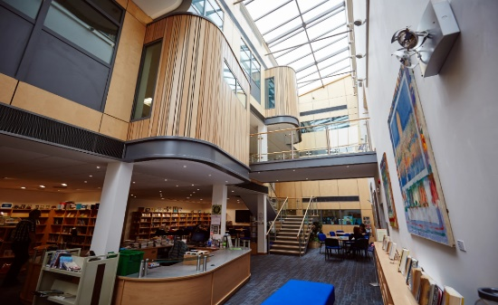

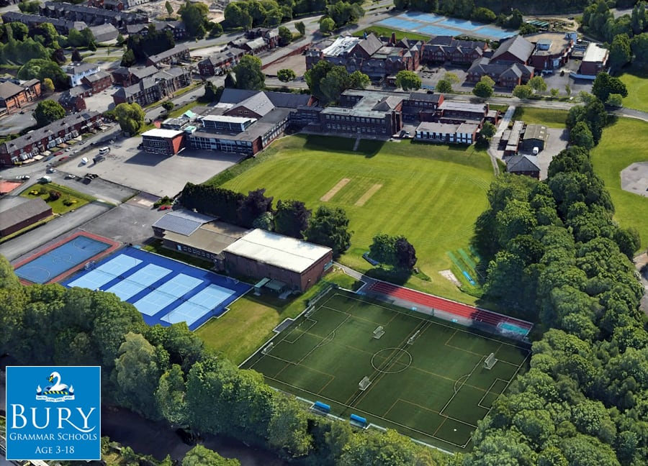

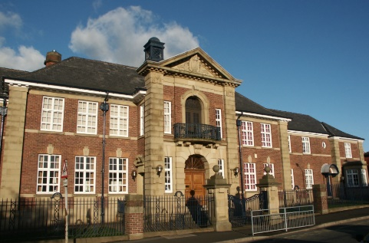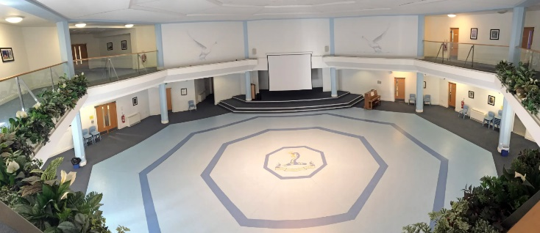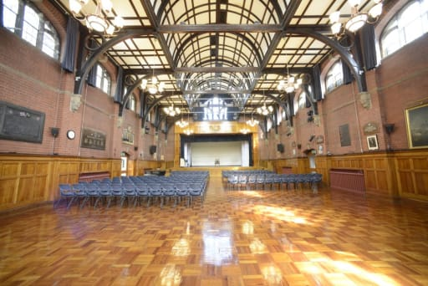

**HOW TO GET TO BGS**

Our Schools are based in the heart of the Lancashire countryside in the centre of Bury and are very easy to reach with the M66, M60 and M62 just minutes away. It is a five-minute walk from the Bury Interchange.

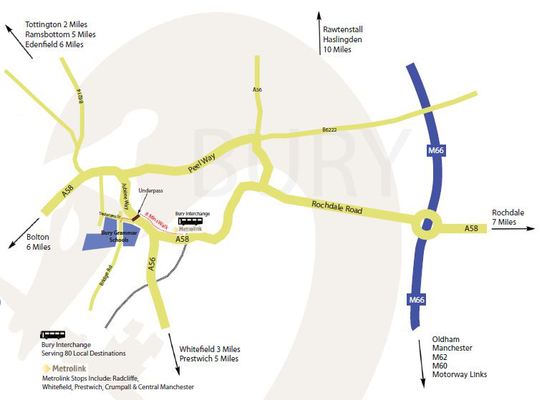

Bury Grammar School is a leading academic institution and the school of first choice for pupils, parents and staff in the area.

**BURY GRAMMAR SCHOOL IS CURRENTLY SEEKING TO APPOINT A**

**Head of Development**

Founded in 1570, Bury Grammar School is an independent day school for pupils aged 3 to 18 years from all backgrounds. Our Founders’ ethos was to create a school where children from all backgrounds would thrive, and we are still true to this ethos today. Our successful means tested bursary programme ensures diversity in our pupil population through offering financial support to those families for whom an independent school education would otherwise be unattainable. Our bursaries are funded from our endowment funds, donations and from general fee income. Currently 1 in 9 senior school pupils receive means tested support and the average bursary is 80% of the fees.

The School has in place a small, established and highly successful Development Team, led by the Head of Development. Recent campaigns include the Sports Campaign and the 450 Bursary Campaign, both of which raised considerable funds for the School.

Due to the retirement of the current Head of Development we are seeking to appoint a new individual to this role; someone with drive and energy who can continue to develop and progress the outstanding work we have seen from the Development Team over the past several years. The School has strong links with donors, Trusts and friends of the School and is now ready to embark on a new and exciting next stage of development. The School has recently invested in a new database and CRM package, ToucanTech software, through which we aim to become even more connected to our BGS community and to maximise the benefits of this for all.

Cultivating, maintaining and leading high-quality relationships with donors who are capable of making transformational gifts to the School is a key element of the role as is continuing to instil a culture of philanthropy across the School and wider BGS community. Improving alumni engagement, large event management and setting strategy for the department are also key. As the leader of this important area of school life, the Head of Development will report directly to the Bursar with input from the Principal and Headmaster.

Bury Grammar School and the Development Team have thrived over recent years and this position offers an opportunity to continue to drive change. The postholder will take further steps to ensure that this department is fully integrated into school life and that it serves past, current and future pupils and members of the BGS community.

Ideally, the candidate will be working 37.5 hours per week, Monday to Friday working throughout the year including the school holidays. The school would be willing to consider part time working for the post.

**Applications**

Caithness Consulting have been appointed by Bury Grammar School to manage the recruitment process for this role on their behalf. We welcome initial confidential discussions with potential candidates who may require some questions answered before deciding to apply. Should you wish to do so, please e-mail our lead consultant, Peter Caithness, on [peter@caithnessconsulting.co.uk](mailto:peter@caithnessconsulting.co.uk) to arrange a convenient time.

**To Apply**

Please send a copy of your CV and a covering letter initially to [peter@caithnessconsulting.co.uk](mailto:peter@caithnessconsulting.co.uk)

Closing date for applications: Monday, 22nd March, 12 noon.

Interview date, if shortlisted:29th March 2021.

Interviews will take place face to face at the school. PPE and social distancing will be in place.



**BURY GRAMMAR SCHOOL**

Job Description

**Head of Development**

Reporting directly to the Bursar and in close liaison with the Principal and Vice-Principal, the post holder will be responsible for:

*Supporting the Schools’ vision, ambitions and achievements through fundraising, and specifically:*

* Plan and agree the Development strategy and targets with the Executive.
* Work towards and support the School’s vision and current objectives as outlined in the School’s Strategic Plan.
* Raise the profile of the Development Office and help embed a culture of fundraising at the School and within the BGS Community. Create awareness of the importance of the work carried out by the Development Office, its value within the School community and ensure that all members of the School community are kept informed of its work.
* Maintain relationships with other post holders in similar independent schools in the North West.

*Fundraising Programmes and specifically:*

* Build upon the existing fundraising strategy and devise new strategies for bursary and other projects. Creating appropriate strategies and targets for different donor and potential donor types. Working closely with the Executive, build and develop donor stewarding and contact strategies, including (but not limited to) legacy and major gifts, regular giving, trusts, businesses etc.
* Build meaningful on-going relationships with donors who will include, new and current donors, friends of the School, current and former parents, alumni, trusts, current and former staff, and local businesses.
* Devise, implement and co-ordinate gift acknowledgement.
* Create stewardship strategies for all levels of donor and maintain relationships with donors at all levels.
* Articulate the needs of the School, both orally and in writing, to potential supporters, including specific details of projects for which the School is seeking funds, representing the School, its ethos and culture appropriately and effectively.
* Develop and implement an ongoing programme of online PR using (for example) social media, online newsletters, ToucanTech online platform, websites etc.
* Ensure the production of up-to-date, appealing and attractive supporting printed materials where appropriate.
* Provide advice on all types of tax-efficient giving and manage tax reclamation efficiently, in collaboration with the Finance team.
* Maintain relationships with donors at all levels.
* Initiate fundraising and awareness events (including virtual events), social activities, reunions, and entertainment of prospective and existing donors.
* Be present at School events such as Prize giving, concerts, lectures and productions etc. where donors and potential donors may be present in order to steward, forge and maintain relationships.
* Ensure all of BGS’s fundraising activities are in accordance with the regulations and guidance set out by the Fundraising Regulator.
* Undertake relevant research in order to understand better potential donors’ attitudes and needs to influence future campaign planning.

*Management of the Development Office and, specifically:*

* Line manager two members of staff, who have key responsibilities and roles within the office, maintaining excellent working relationships and building team spirit.
* Work in collaboration with the team to maintain, improve and develop administrative systems and ToucanTech. Ensure accuracy of records at all time.
* Manage the Development budget in accordance with guidance from the Bursar.

*Alumni Relations and, specifically:*

* Ensure that the ToucanTech site content engages our alumni community, has content that alumni want and that it is update at all times. Use the software to segment data and communications where necessary. Join online user groups to learn how other schools use the software and ensure our system runs efficiently and always uses the most up to date functionality.
* Use ToucanTech to:
  + Control data – ensure we can segment data as required
  + Grow the BGS alumni/community
  + Create engaging online content regularly (daily/weekly) that the community want to see – use market research feedback to help steer content.
  + Communicate with the community through this platform
  + Manage events, including ticketing and seating plans
  + Promote mentoring and careers – link with LinkedIn page
  + Run fundraising campaigns
  + Track all activity.
* Maintain excellent links with the Old Girls’ and Old Boys’ Associations, their committees and all connected associations.
* Maintain and improve upon the existing programme to encourage students and alumni to maintain lifelong links with the School. Undertake market research to monitor alumni engagement, explore what alumni want from the School and to identify potential new donors.
* In conjunction with the alumni Associations’ Committees and the Heads, organise reunions and events to strengthen relationships between the School and its former students and parents.
* Ensure that former students receive regular information about the School.
* In collaboration with the Bursar and Heads promote opportunities for alumni to contribute to the life of the School, recording these as appropriate.

**Person Specification:**

|  |  |  |  |
| --- | --- | --- | --- |
| Person Specification – Head of Development | | | |
|  | **Essential** | **Desirable** | **Method of assessment** |
| **Qualifications** | Degree or equivalent qualification.    Evidence of continued career  development. |  | *Certificates and application* |
| **Experience** | Evidence of strategic leadership in a senior marketing and or fundraising role.  Proven experience in campaign management, online marketing including website management, social media and the production of marketing collateral.  Proven experience in delivering high-quality events including “virtual events”.  Proven experience of budget management and financial planning.  Proven experience of successfully leading a team. | Experience with and membership of the IDPE and its professional practices.  Experience in the independent education sector.  Experience of successfully making a fundraising asks. | *Application form and references* |
| **Skills and**  **Knowledge** | Excellent, high calibre, **interpersonal skills** and an ability to establish rapport quickly and professionally with a diverse range of stakeholders, including donors, current parents and pupils and alumni. Must be comfortable in the “limelight”.  Outstanding and highly persuasive **writing skills**, with the ability to prepare powerful editorial, and motivating fundraising communications.  A **creative** thinker, with enthusiasm to suggest new ideas, energy and willingness to work in a busy and vibrant team and the flexibility to adapt to new opportunities.  Strong **project management and organisational skills**, with an ability to set clear objectives, milestones, deliver against timelines and to influence staff across BGS to support initiatives.  A **positive and self-motivated** individual, able to work both with minimal supervision and as a proactive and supportive member of an ambitious team.  Practical knowledge of **GDPR** and understanding of the need for sensitivity and confidentiality in dealing with personal data.  An understanding of the need to adhere to **policies and procedures**, some of which are legal requirements.  A **commitment** to the independent sector in education. | Knowledge of charity law aligned to tax-effective giving, legacies,  Knowledge and understanding of fundraising best practice. | *Application form, references* *and interview* |
| **Personal competencies and qualities** | A strategic thinker with a hands on approach.    Confident communicator with a genuine  interest in independent education.    Resilient, personable, tactful, hard working.    Enthusiastic, flexible, creative, self-motivated.  Natural authority, leadership by example, personal integrity.  Drive to see initiatives through, an eye for detail.    An open mind and a sense of humour.    Willingness to maintain a busy schedule, including travel (UK and possibly abroad) and some evening and weekend commitments. |  | *Application form, references* *and interview* |

**GUIDANCE NOTES FOR APPLICANTS**

**Rehabilitation of Offenders/Disclosure and Barring Service**

A criminal conviction will not necessarily be a bar to your employment. Bury Grammar Schools comply with the Disclosure and Barring Service’s Code of Practice and will consider the suitability of all applicants on merit and ability.

The Rehabilitation of Offenders Act 1974 entitles people who have been convicted of a criminal offence carrying a sentence of up to 30 months’ imprisonment and who have completed the appropriate period of rehabilitation to regard their conviction as “spent”. “Spent convictions” can then be regarded as never having occurred.

The Rehabilitation of Offenders Act 1974 (Exceptions) Order 1975, however, exempts certain types of employment such as working in a school from the provisions of the Act. In addition, the Police Act 1997 required Police checks for all posts that come into contact with under 18s and vulnerable adults on a regular basis. Appointment to this post will require the post-holder to undergo checks by the Disclosure and Barring Service before commencing any duties which could bring them into contact with children.

Any information disclosed will be kept in strict confidence and used only in consideration of your suitability for the job for which you are applying. If you fail to disclose relevant information requested at any stage of the recruitment process, then your employment could be subject to withdrawal of contract, dismissal or disciplinary action in accordance with Bury Grammar Schools’ policies.

**Evidence of permission to work in the UK**

Prior to being permitted to commence employment with Bury Grammar Schools, you will be required to produce documentary evidence of your right to work in the United Kingdom. You could provide, for example, either a British passport or a passport or a National Identity Card from an EEA Country or Switzerland; alternatively, a document showing your permanent UK National Insurance Number and your full UK Birth Certificate.

A full list of acceptable documentary evidence is available on request. Original documents must be provided at interview stage. For further information, please refer to the Home Office website ww.bia.homeoffice.gov.uk.

**Safer Recruitment**

Bury Grammar Schools are committed to safer recruitment and safeguarding pupils. Any appointment will be subject to successful DBS clearance, satisfactory reference and confirmation of medical fitness for the post.

**Bury Grammar Schools welcomes Diversity and is Inclusive of all Cultures,**

**ensuring all are respected and valued for who they are as an individual, and as a group.**

**HOW TO APPLY**

**Completing your application form**

To apply for this position, please complete all sections of our application form. You are also required to complete a covering letter of application, but in Microsoft Word format only. Please do not submit your CV, even to supplement your application as this will not be considered.

**Employment**

Please give us details of your complete work history since leaving school/tertiary education. This should include information on your current and past employers, job title, dates employed and salary. Please explain any breaks in employment when detailing your full work history. You need to demonstrate clearly how your experience, knowledge, skills and abilities match those required in the job, as detailed in the Person Specification.

Where possible you should give examples of when you have used specific skills and abilities or needed to develop competencies in the relevant areas. You can draw on elements from any aspect of your life, such as education, work, home or community life, as long as you focus on its relevance in comparison to the needs of this job. It is important that you fully complete your application as all shortlisting decisions are based on the essential criteria in the person specification and only those candidates who are the closest match to the identified criteria will be invited for interview.

**References**

Please give details of 2 referees who can comment on your suitability to do this job. At least one reference must be from your current or latest employer and your references must cover your last three years of employment. It is BGS policy to request references prior to interview and these are verified as genuine.

BGS reserves the right to contact your current or latest employer following the interview and prior to offering a contract of employment.

In providing the names of referees, you are agreeing that Bury Grammar Schools may ask their opinions on your character in relation to this application. These opinions, given in trust, will remain confidential.

**General**

By signing and returning our application form you consent to Bury Grammar Schools using and keeping information about you, provided by you, or by third parties such as referees, relating to your application or future employment. If you are unsuccessful then your information will be retained for six months from the closing date. If you are successful, then your information will be transferred to your personnel file.

**Keeping your information secure**

Personal and Monitoring information is treated as strictly confidential and will be dealt with in accordance with the General Data Protection Regulation and our Data Protection Policy.

**Assistance with your application**

If you need any assistance in completing your application, please contact the HR Department on 0161 696 8600.