

**Philanthropy & Development Manager**

**Candidate Pack**

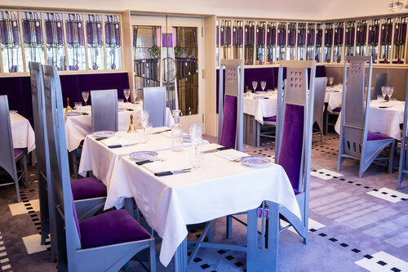

**About The Willow Tea Rooms Trust**

The Willow Tea Rooms Trust set out with a vision to restore, preserve, and sustain Miss Cranston’s Willow Tea Rooms, which were designed by Charles Rennie Mackintosh. This was achieved thanks to the generous support of their donors.

However, while they have restored this beautiful historic building for the nation, they still need support to help to protect and sustain this special place. As custodians of the only Charles Rennie Mackintosh building in the city centre still open to the public, fundraising is vital to allow them to carry out the essential preservation that this unique heritage building will continue to need in the future. By continuing to preserve the building they can ensure Charles Rennie Mackintosh’s legacy lives on to inspire and engage many generations to come.

On-going support also means that they can continue to bring their heritage to more people through imaginative Creative Learning and Education programme: ‘The Willow Welcomes’. Inspired by the legacies of Charles Rennie Mackintosh and Catherine Cranston, this programme aims to bring the building alive for people of all backgrounds, regardless of economic, cultural, and societal barriers.

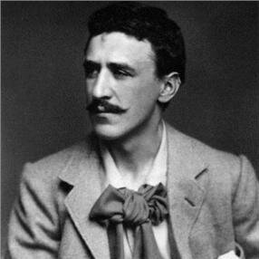

**The Willow Tea Rooms Trust Importance**

The tearooms, now known as Mackintosh at the Willow, are one of the architectural jewels in Scotland’s crown. And as such, it will need lots of care over the years to come as all buildings do.

Since the loss of the Glasgow School of Art, Mackintosh At The Willow has become the only building designed by Mackintosh that continues to fulfil its original function: as a working tea rooms. This level of experiential authenticity cannot be overstated in terms of the feedback provided by visitors. The building highlights the important contributions that Mackintosh and Miss Cranston made to Scotland’s story. By protecting the building, the Trust helps to keep their story alive. Without regular repair and conservation, they would risk losing the tearooms and with them, part of Scotland’s rich cultural heritage.

Based in Glasgow’s city centre, Mackintosh At The Willow, is easily accessible via public transport for visitors. As part of the renovation, the Trust ensured that the building can be enjoyed by as many people as possible by including lifts, ramps, and hearing loops. School children, design students and members of the local community relish the fact they are standing where Mackintosh stood.

Coupled with the meticulous care that has gone into the restoration and recreation of every object in the tearoom, the sense of ‘stepping back in time’ is palpable. The experience is immersive, and richer for it.

There can be a preconception that heritage sites are only for those of certain privileges, such as wealth, ethnicity, and physical and mental ability. This often discourages people from accessing heritage and creates a lack of a sense of civic ownership. A free, targeted programme of engagement can help to reconnect people to their cultural environments and national treasures.

By widening access, Scottish heritage can act as a bridge to bring people together through activities and education, which help to tackle social isolation, enrich communities, and ignite creative responses that improve well-being. The Willow Tea Rooms Trust aims to widen access to the building and use heritage to inspire and empower visitors. As well as providing free workshops to schools, colleges, universities, and community groups, they also have specific groups they like to work with: minority groups, vulnerable adults, and older visitors, such as those diagnosed with dementia.

Since the March 2020 lockdown, their engagement plan includes both digital content and an outreach programme to lessen barriers to people enjoying the building. However, there is nothing quite like a visit to the building itself and there are myriad tangible and wider benefits to Mackintosh At The Willow (as the building is now known) being a resource for schools and communities. Visiting Charles Rennie Mackintosh’s iconic Willow Tearooms brings his work to life in ways no classroom or virtual tour can hope to achieve.

Both Charles Rennie Mackintosh – a Glasgow boy, not from a wealthy background – and Catherine Cranston – a female entrepreneur ahead of her time – are inspirational. Their stories can empower those who may feel they do not have ‘what it takes’ - either personally or in terms of access to opportunity - to achieve their goals. Rich community projects provide social and vocational benefits for adults: from meeting new people to gaining new skills.

**The Trust are now able to appoint their first permanent dedicated fundraising member of staff. You will be working with an influential Board who are fully supportive of fundraising and active ambassadors for the Trust.**

**Philanthropy and Development Manager**

We are looking to attract someone with a wide variety of experience to this key role. Reporting directly to the Executive Director. You will demonstrate:

* Success in regular giving and supporting mid-level giving and major gift activity
* Excellent writing skills enabling you to able articulate the need for funding from a variety of donors and potential donors
* Fundraising project development, including budgeting
* Experience and proficiency in using a dedicated CRM
* Excellent interpersonal and communication skills, enabling you to interact effectively with internal and external contacts at all levels
* Outstanding networking and negotiation skills, including the ability to represent he Trust at internal and external events
* Ability to work and contribute within a team environment and respond to target driven performance reviews
* Solid numeracy and literacy skills

**Salary & Benefits Package**

The salary is C£35k and there is a great deal of flexibility around hours of work, and work location.

**Benefits Include:**

5% Employer pension contribution.

**Annual Leave**

During the first 12 months of employment, 28 days holiday with an extra day added per year of service to a maximum of 33 days holiday.

The Job Description and Person Specification can be downloaded from our website.

Formal application is by CV and covering letter and we would encourage you to arrange an informal chat with our lead consultant, Eilish McDowell on 07720249200/01382 522919 to talk through this exciting opportunity and to decide whether this is the right career move for you.



**Closing Date:** 5pm Monday 5th July

**Interview date:** Week commencing the 19th July. It is hoped that interviews will take place in person but there will be an option for virtual interviews as circumstances dictate.