

24 QUEEN STREET DUMFRIES DG1 2JF

mail@dumfriestrust.org.uk

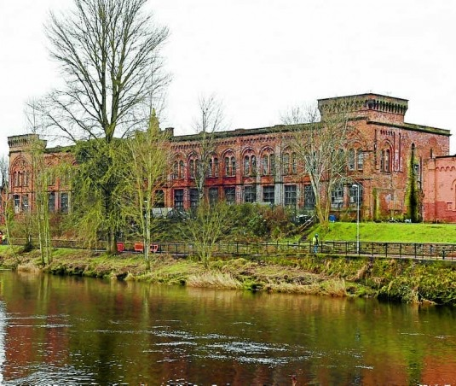

R O S E F I E L D M I L L S

**Project Development Manager**

**Job Specification**

June 2024

**Rosefield Mills Project Development Manager - for Dumfries Historic Buildings Trust (DHBT), a Dumfries-based Building Preservation Trust.**

**(Full time 35 hours pw, Fixed Term for an initial 18-month period with scope to extend for a further 18 months, subject to funding.**

This is an exciting opportunity to play a key role in DHBT’s most significant project to date, driving forward the restoration of an iconic riverfront building, a significant and prominent part of the former Rosefield Mills, in Dumfries.

DHBT is seeking an experienced Project Development Manager to work collaboratively with the Trustees of the charity, the community, funders and wider stakeholders, to develop the project.

This will focus on the riverfront building at Rosefield Mills which the Trust acquired with the support of public donations and grant funding in 2018. The aim will be to refine and deliver our vision through a series of planned stages from a starting point of the Category B-Listed vacant building at risk, where we have undertaken recent emergency repairs, up to completion of the restoration and sustainable re-use of the riverfront building, whilst contributing to the wider regeneration of the former Mills site which extends over 10 acres.

**Background**

Dumfries Historic Buildings Trust (DHBT) was the first Building Preservation Trust to be founded dedicated to Dumfries and the surrounding area with the intention to participate in ensuring that no more of the distinctive vernacular buildings and historic architecture of this beautiful area of Scotland is lost. The Trust seeks to work collaboratively with Dumfries & Galloway Council, the local planning authority, other charities or organisations with broadly similar aims, and with all relevant government or other funding agencies national or local who may be in a position to support its work.

The Trust was established in December 2011. Like other Building Preservation Trusts, it is often working with historic buildings which, for one reason or another, present a high level of risk and are therefore not being taken up directly by public or private organisations or developers.

The Trust seeks to pursue sympathetic solutions for the buildings entrusted to it while also being an advocate of the importance of using traditional materials and skills, and offering elements of training and experience. Steady and unremitting maintenance should ensure that our building projects retain their heritage values and contribute to the outstanding global imperative of our time: to achieve carbon capture and to embody a philosophy of stewardship of the earth’s resources.

Indispensable in the Trust’s vision for its projects is to pay attention to the context or setting – social, economic and cultural – in which the projects lie. In the case of our current largest project, the relict of the formerly vast Rosefield Mills complex of the 1880s, our waterfront building has the potential to be a beacon for the deprived local community; an economic lever on account of its size and relationship to local housing, cultural assets (e.g. St Michael’s church almost opposite) and town centre activities; and its breath-taking location on the river bank which has led more than one commentator to compare it to the former and often palatial industrial buildings of Venice, many of which have found sustainable new functions.

**Employee Benefits**

The role, for which funding has been made available from The Pilgrim Trust and the UK Government’s Shared Prosperity Fund, for an initial period of eighteen months, is critical to the success of the project. The Trustees, meeting four times a year, and members of the Rosefield Mills Working Group (RMWG) meeting monthly, are all volunteers. The Project Development Officer will initially be the sole employee of the Trust, with further support staff to be engaged as funding permits. Together, our Trustees and volunteers have a wide range of skills, passion and experience and will support the PDO as appropriate. The post-holder will work closely with, and with the support of, the Working Group, and will report regularly to the Board of Trustees.

Benefits include:

* Pension scheme Auto enrolment in the NEST pension scheme, or similar, with an employer contribution of 5%.
* 32 Days Holiday inclusive of Bank Holidays.
* Flexible working hours. Time off in Lieu for additional hours worked.
* Mileage and Expense payments.
* Office-based in Dumfries. May consider flexibility over some home-based work.

**Job Specification**

The over-riding role of the Project Development Manager (PDM) is to ensure that the defined planning stages are completed in full and on time where possible.

* This will entail working in partnership with the Trustees, the Rosefield Mills Working Group (RMWG), the Design Team and consultants (when appointed), with local and national government and organisations appointed by them, and with the rich spectrum of local entities representing the needs and wishes of the local community, to the point where – ideally - the Trust’s property has been repaired, re-serviced, is in use, and is ready to play its part in the wider context of the other elements of the 10-acre former Mills site.
* The PDM will be employed by Dumfries Historic Buildings Trust, and will report to the Board of Trustees.
* The PDM will have a secondary role in supporting Learning and Outreach activities relating to the former Mills and to the DHBT Rosefield Mills project.
* The PDM will take a keen interest in any other projects of the Trust, while focusing most energy and attention on the Rosefield Mills project.
* Possibility of extension to employment, subject to funding.

**Key responsibilities and accountabilities**

* To engage with the community to identify and market test viable options for uses in the riverfront building. The cultural heritage of the site will be of paramount importance alongside the need for the building to be vibrant and economically sustainable.
* To co-produce – with the Working Group – an action plan to realise the delivery of an operational riverfront building. This action plan will form the activities of this role and will be reported against regularly.
* To take the lead role on behalf of the Trust in ensuring that the successive stages of the project are properly planned and carried out in a timely manner, honouring the conditions of any grant which may be applicable.
* In relation to works to the structure of the Rosefield Mills, to take the lead in ensuring that the Trust’s design, technical, business planning, functional and operational requirements and ambitions are fully realised through the design, tendering and construction process and that the project is delivered safely, on programme and within budget.
* To ensure effective communication between all entities and levels of responsibility including the Trustees, the RMWG, the contractors and consultants.
* To ensure, with the support of the Chairs of the Board of Trustees and RMWG, that appropriate reporting structures are in place and observed.
* To be available as required to engage with the local community and with local and national organisations with complementary interests or responsibilities, including hosting site visits, making presentations and generally increasing the profile of the project within the town, the region, and nationally.
* To be on site regularly, to inspect site progress, and to be involved in ensuring the general safety and security of the site.
* To support the Trustees in making applications for funding, identifying opportunities, and acting as key point of contact for funding partners.
* To ensure, with the support of the Board and the Working Group, that requirements for reporting to funders are met, during and on completion of the project.

**Key Qualifications:**

* Experience in working with community groups, funders and key stakeholders and delivering a complex project in that context, would be essential.
* A passion for historic buildings and a passionate commitment to contributing locally and nationally to their sustainable future through appropriate and imaginative re-use and their continuing conservation and maintenance.
* Strong leadership qualities. At the same time, an ability to work as a member of a team, and to recognise the contributions of others.
* Strong communication and networking skills,
* Strong organisational, project management and report-writing skills.
* Experience of project scheduling and delivery to deadlines.
* Experience of fundraising and of making grant applications

**Desirable additional qualities**

* Experience of significant and complex design/construction projects within a Conservation Area and/or involving listed buildings
* Experience of working in rich cultural and/or social environments.
* Knowledge and experience of achieving community benefits through capital projects.
* A demonstrable knowledge through education and track record of the historic and social environments of Scottish historic towns.

**Salary**

In the region of £33,000 to £35,000 dependent on experience.

.